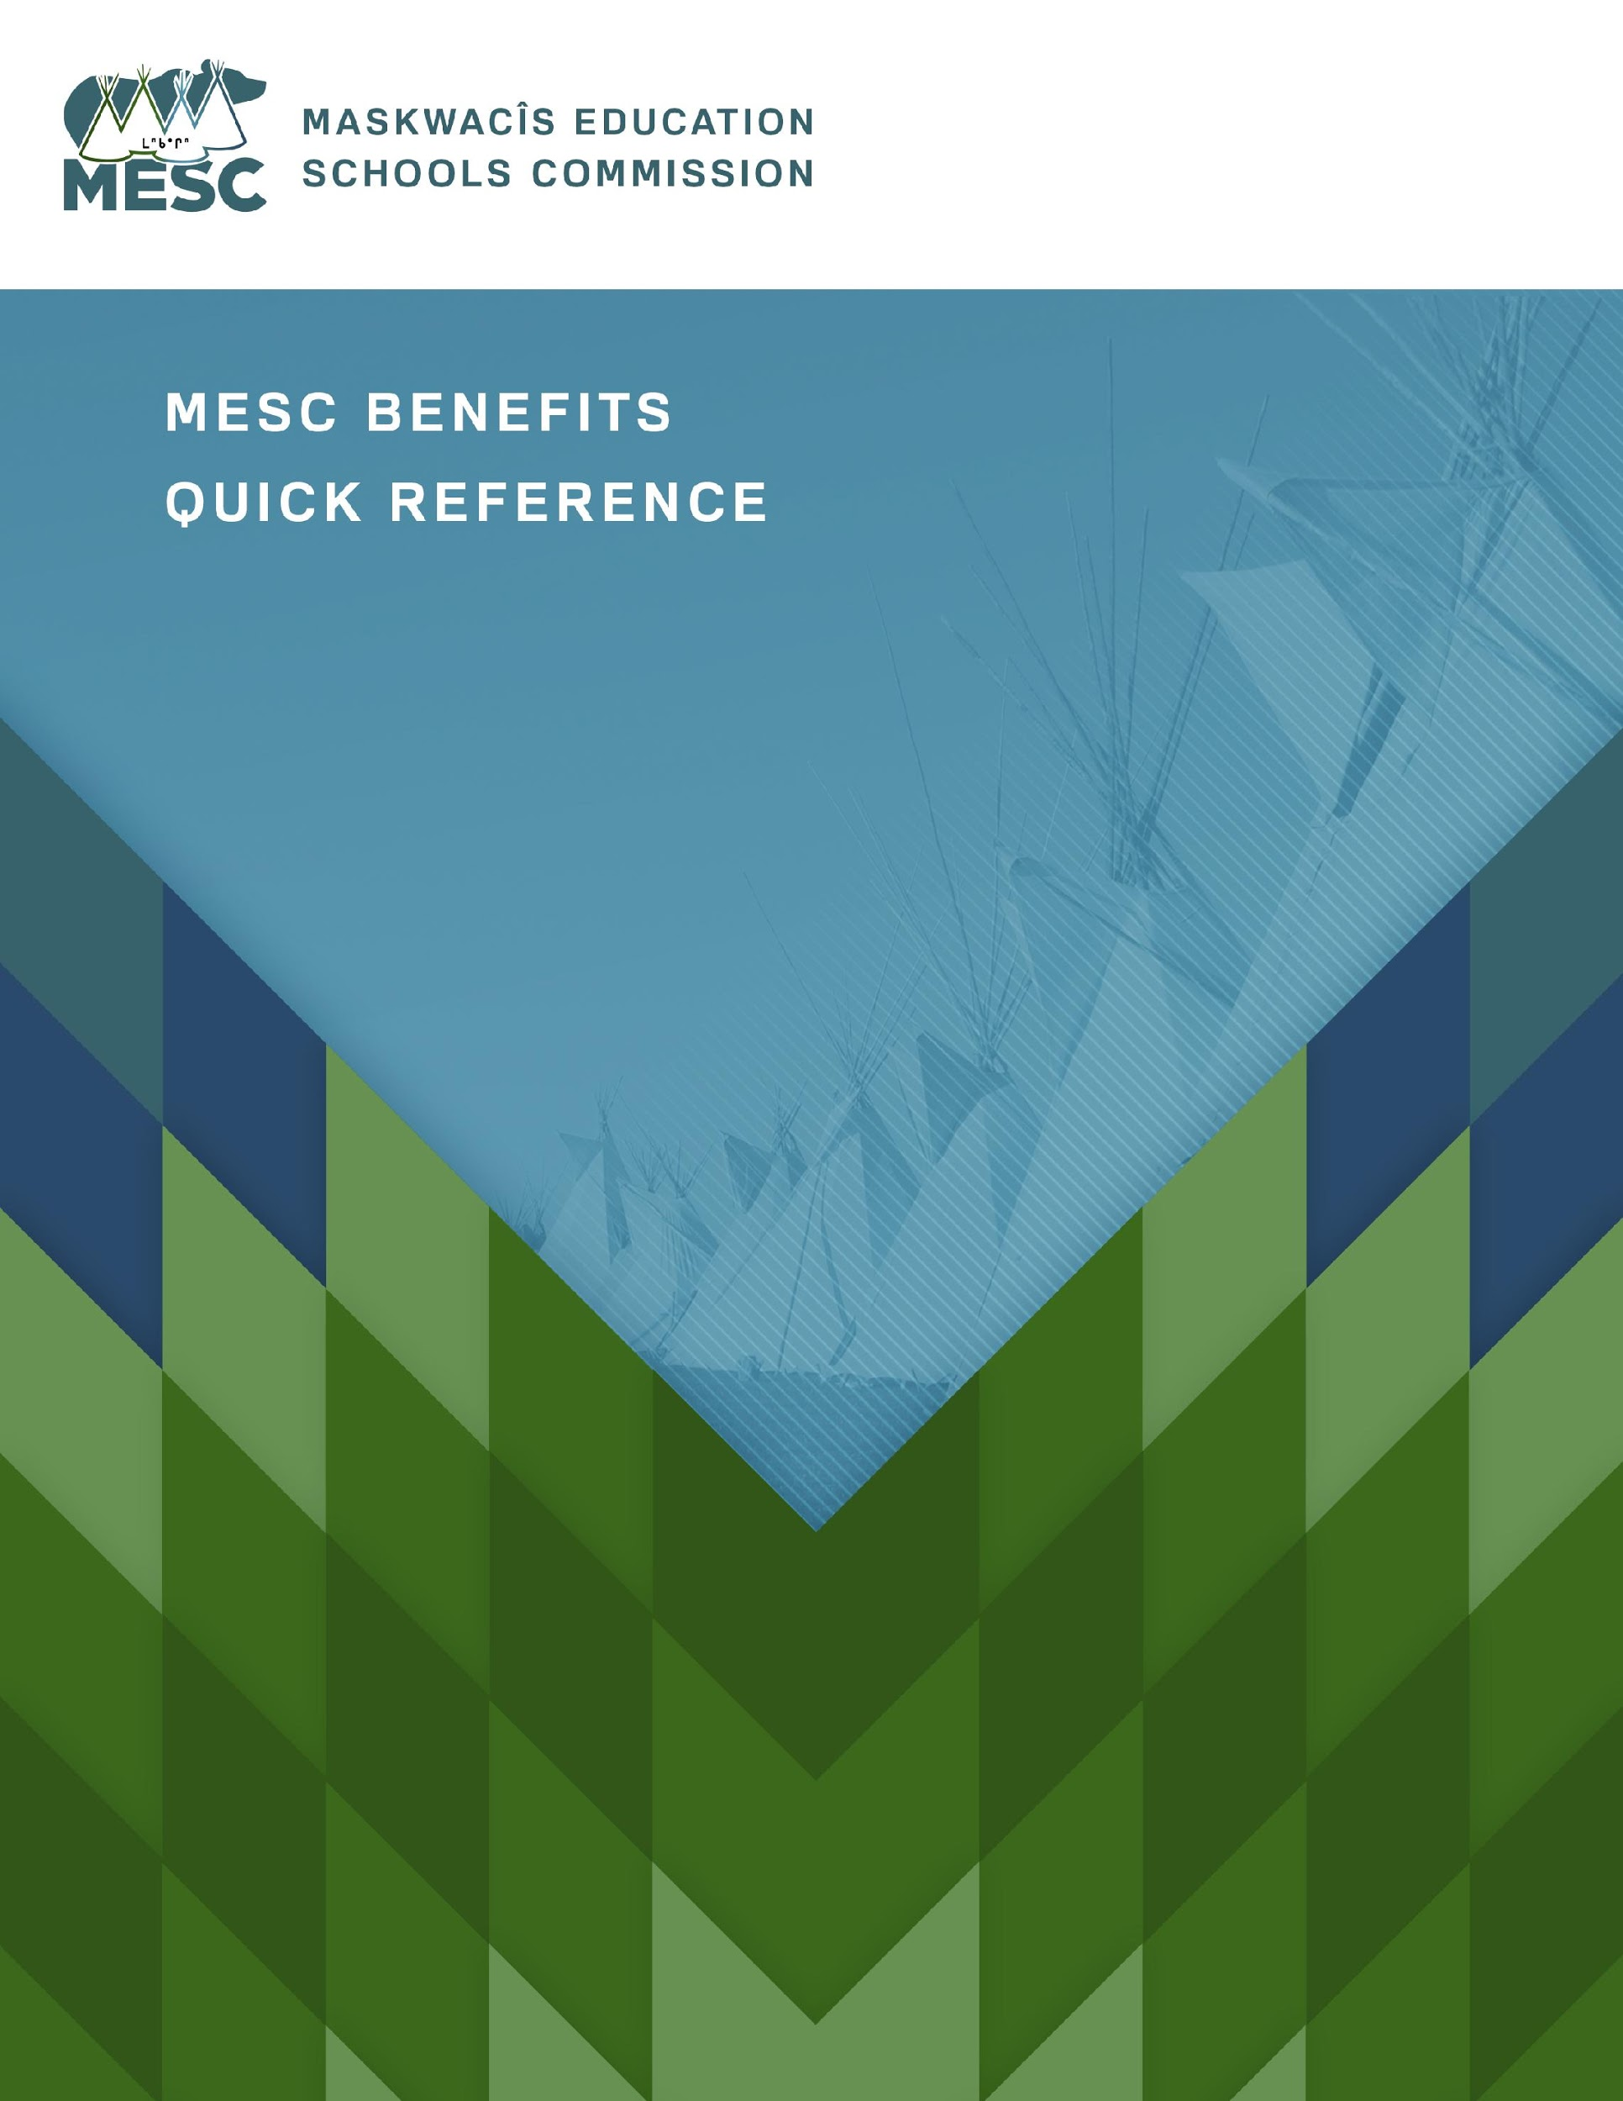

Dependent Coverage includes:
- your married spouse
- your common-law spouse who has been living with you in a conjugal relationship for at least 6 months
- your unmarried children under age 21 as long as they are not working more than 30 hrs. per week, or under age 25 if they are full-time students
- children who are incapable of supporting themselves because of physical or mental disorder are covered without age limit if they disorder begins before they turn 21, or while they are students under 25, and the disorder has been continuous since that time
- dependents can include children for whom you have legal guardianship as long as you have the supporting legal documentation.

Marion Wells
Director of Health and Wellness
People Services Branch
Maskwacis Education Schools Commission
marionwells@maskwacised.ca
780-585-3333 ext. 242
Great West Life Benefits Plan Information

You will remain on your existing plan until July 1, 2018 at which time that one ends and the new MESC plan begins.

On or after July 1st, sign up and manage your new plan on-line.

Go to the Great West Life site.
https://groupnet.greatwestlife.com/public/signin/login.public

When signing in for the first time click: “New User? Register now to go green…”

Plan #172907
Plan name: Maskwacis Education Schools Commission
ID#: Will be sent to you, or contact Marion Wells

If you have trouble you can contact GWL at 1-800-665-2648

From here you can:

- print your personal direct pay drug card & health travel card
- see a list of your benefits
- update personal information
- update list of dependents
- fill out claim forms and send them electronically
- print out claim forms
- review what you have claimed during the last 24 months
- track a current claim
- look up your next purchase dates for vision and dental
- learn about your prescription drugs
- take a personal health quiz which then offers helpful suggestions
This site contains a lot of information about your personal plan and general health. Check it out.

Some claims cannot be submitted electronically and must be sent by mail to:

Winnipeg Benefit Payments
PO Box 3050 Station Main
Winnipeg MB
R3C 0E6

Basic summary

Insurance for Status Employees

Accidental Death and Dismemberment: 2X Salary death benefit
* Not taxed upon collection. See booklet for more details

Dependent Life: $15,000 spouse; $7,500 per child
* Not taxed upon collection

Short Term Disability: 66.67% of salary to a maximum of $1,500/week
* Not taxed upon collection
* There is a 1 week waiting period except for injury or 1st day hospitalization

Long Term Disability: 66.67% of salary to a maximum of $6,000/month
* Not taxed upon collection

Critical Illness insurance: $10,000. per employee per lifetime
* Not taxed upon collection
* There is a specific list of qualifying critical illnesses including strict criteria. See
website/booklet for details

Insurance for Non-Status Employees

Accidental Death and Dismemberment: 2X Salary death benefit
* Not taxed upon collection. See booklet for more details

Dependent Life: $15,000 spouse; $7,500 per child
* Not taxed upon collection

Short Term Disability: 66.67% of salary to a maximum of $1,500/week
* Maximum benefit period = 17 weeks
* Not taxed upon collection
* There is a 1 week waiting period except for injury or 1st day hospitalization

Long Term Disability: 66.67% of salary to a maximum of $6,000/month
* Taxed upon collection

Critical Illness insurance: $10,000. per employee per lifetime
* Not taxed upon collection
* There is a specific list of qualifying critical illnesses including strict criteria. See
website/booklet for details

Health Benefits

- Pay direct cards

- Eligible drugs paid at 100%
  - Plan covers generic drugs only, unless you have a note from your doctor explaining why you need the brand name
(Not all medications prescribed by your doctor are covered and some require a predetermination to see if they qualify)

- Many Vaccinations are covered at the customary fee
  - If your provider charges above the customary fee you will be responsible for the difference. Cost of dispensing fees are extra. See your plan for more details

- Paramedic and professional practitioners: $750 / year / per dependent / per practitioner
  - Acupuncture, Chiropractor, Masseurs, Naturopaths, Osteopath, Physiotherapy, Podiatrist, Psychologist. See your plan for more details. Some practitioner direct bill others do not

- Vision: $700 per adult every 24 months
  - $700 per child every 12 months under age 18
(restriction apply, see website/booklet for details)

- Critical Illness insurance: $10,000 per employee per lifetime
  - There is a specific list of qualifying critical illnesses including strict criteria. See website/booklet for details

- Diagnostic and treatment support services (Best Doctors Services)

- MedAssist: out of country medical travel insurance
(Restriction apply. See website/booklet for details)

All benefits, except Vision, reset on the Calendar Year (January 1st)
Vision benefits reset on the anniversary date of service:
- every 24 months for adults
- every 12 months for children under 18

Check online to see your Coverage Balances and Next Purchase Dates.

Dental Benefits

$3000 maximum per year / per dependent
Reimbursed at 100% for preventive and restorative services and 80% for major restorative services.
*The standard Fee Guide, that Great West Life uses, may vary from the fees your dentist
charges. Therefore, even though some services are covered at 100%, you may end up
with an unpaid balance that you are responsible for.

Orthodontia
$3000 lifetime maximum per child reimbursed at 50%
* Coverage terminates on child’s 19th birthday as long as treatment started before their
18th birthday.

Employee Assistance Program

This program is totally confidential. All the employer gets to see is the number of people using this service — no names, no details.
Provides a full suite of services including
Counseling
- free counselling sessions provided to help address your immediate needs. Can be delivered in-person, by phone, or through e-counselling
Self-development
- Take e-learning courses to improve Financial or Life skills.
Health management
- Provides a huge selection of Health information and tools including quizzes, personalized health action plans, e-learning courses and more
Work-life service
- Take personal assessments (personality and vocational tests)
- Professional development
- Counseling for young adults/post secondary students

This service is available 24/7 to you and your dependents
Log in at www.homeweb.ca
Click “Sign up"
Company name is Maskwacis Education Schools Commission. Then fill in your personal information and you're all set. Or call 1-800-663-1142
*The plan can change from time to time
*Always check your plan book or go online for more coverage details

For more information contact:

Marion Wells
Director of Health and Wellness
People Services Branch
Maskwacis Education Schools Commission
marionwells@maskwacised.ca
780-585-3333 ext. 242

Wellness Spending Account

This program is being administered by MESC. Do not submit Wellness Spending Account claims to GWL. These claims must be submitted to the Director of Health and Wellness.

